ASSIGNMENT 3

A) C++ Program to Check Whether a Number can be Express as Sum of Two Prime Numbers

PROGRAM:

#include <iostream>

using namespace std;

bool check_prime(int n);

int main() {

int n, i;

bool flag = false;

cout << "Enter a positive integer: ";

cin >> n;

for(i = 2; i <= n/2; ++i) {

if (check_prime(i)) {

if (check_prime(n - i)) {

cout << n << " = " << i << " + " << n-i << endl;

flag = true;

}

}

}

if (!flag)

cout << n << " can't be expressed as sum of two prime numbers.";

return 0;

}

bool check_prime(int n) {

int i;

bool is_prime = true;

if (n == 0 || n == 1) {

is_prime = false;

}

for(i = 2; i <= n/2; ++i) {

if(n % i == 0) {

is_prime = false;

break;

}

}

return is_prime;

}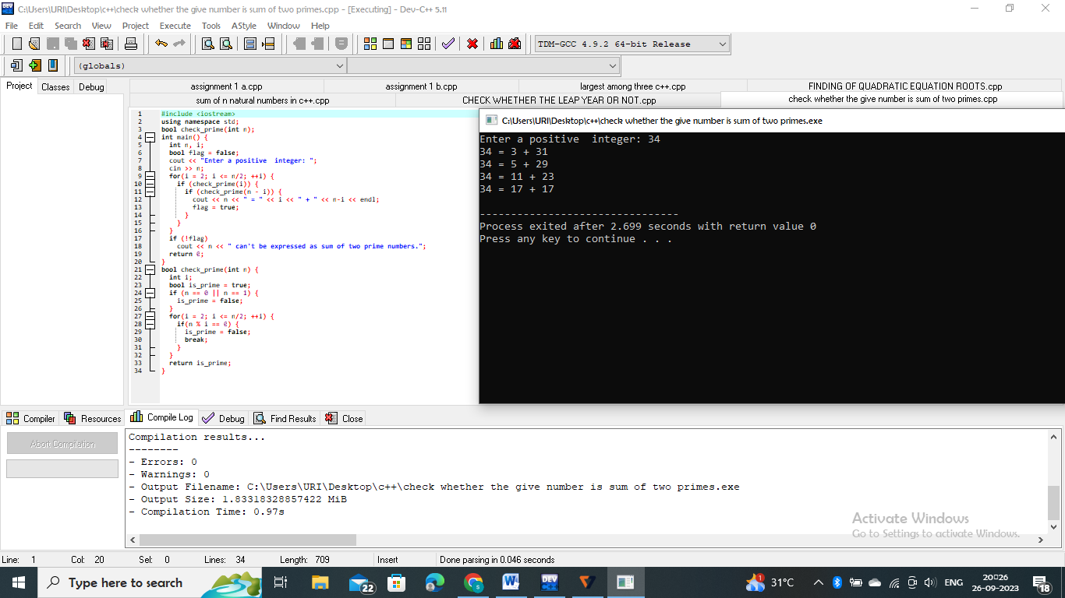

B) C++ program to Calculate Factorial of a Number Using Recursion

PROGRAM:

#include<iostream>

using namespace std;

int main()

{

int n;

long factorial=1;

cout<<"enter the positive number";

cin>>n;

if(n<0)

{

cout<<"error";

}

else

{

for(int i=1;i<=n;++i)

{

factorial*=i;

}

cout<<"factorial of"<<n<<"="<<factorial;

}

return 0;

}

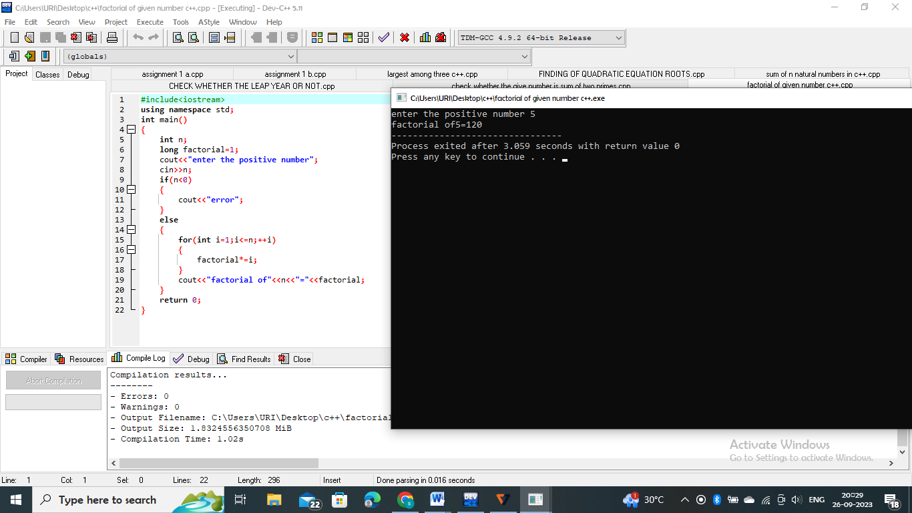

C) C++ Program to Add Two Matrix Using Multi-dimensional Arrays

PROGRAM:

#include <iostream>

using namespace std;

int main()

{

int r, c, a[100][100], b[100][100], sum[100][100], i, j;

cout << "Enter number of rows (between 1 and 100): ";

cin >> r;

cout << "Enter number of columns (between 1 and 100): ";

cin >> c;

cout << endl << "Enter elements of 1st matrix: " << endl;

// Storing elements of first matrix entered by user.

for(i = 0; i < r; ++i)

for(j = 0; j < c; ++j)

{

cout << "Enter element a" << i + 1 << j + 1 << " : ";

cin >> a[i][j];

}

// Storing elements of second matrix entered by user.

cout << endl << "Enter elements of 2nd matrix: " << endl;

for(i = 0; i < r; ++i)

for(j = 0; j < c; ++j)

{

cout << "Enter element b" << i + 1 << j + 1 << " : ";

cin >> b[i][j];

}

// Adding Two matrices

for(i = 0; i < r; ++i)

for(j = 0; j < c; ++j)

sum[i][j] = a[i][j] + b[i][j];

// Displaying the resultant sum matrix.

cout << endl << "Sum of two matrix is: " << endl;

for(i = 0; i < r; ++i)

for(j = 0; j < c; ++j)

{

cout << sum[i][j] << " ";

if(j == c - 1)

cout << endl;

}

return 0;

}

